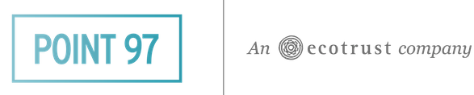

**FOR IMMEDIATE RELEASE**

Media Contacts: Shirley Hancock [shirley@jennacooperpr.com](mailto:shirley@jennacooperpr.com) or 503-781-4324

Jenna Cooper, APR

[jenna@jennacooperpr.com](mailto:jenna@jennacooperpr.com) or 503-880-8881

**Point 97 Announces World Launch of Proven Technologies and Mobile Solutions Addressing Competing, New Demands on Oceans**

*Spatial Planning Company Offers Unique Engagement Strategies, Technologies that*

*Support Strong Coastal Businesses, Healthy Oceans*

PORTLAND, Oregon—(October XX 2013)—At the coastal intersections where economy and ecology sometimes collide, an unusual high-tech company is using a blend of collaboration and new technologies to help divergent groups find common ground—or in this case, common water. These groups include fishermen, tribes, resource managers, recreationists and government, and scale to offshore energy development, shipping, mining, oil and gas, telecom and insurance.

“Think of it as smart land use planning, only on our oceans, where 97 percent of the world’s water resides,” says Ruby Gates, CEO of [Point 97](http://pointnineseven.com/). “New uses of our oceans are constantly emerging, from wave energy to rare mineral mining to tracing the origins of the fish you’re having for dinner. Governments are trying to create policies, but there’s a deficit of data on who is using the ocean, where and why. We build systems that identify those uses, better connecting people to the places where they live and work.”

The marine and coastal spatial planning company uses unique open platform technologies that can finely identify competing interests on the oceans. The Point 97 team--with years of experience working across all fronts---excels at facilitating transparent collaboration between those interests. The Company also offers digital data gathering tools, putting them directly into the hands of the people who historically haven’t had access to that collected information, like fishermen, or tribes.

“The Point 97 team brings creativity and passion to push the frontier for ocean planning and management decision support tools,” says Jay Odell of the Nature Conservancy. “In partnership with us and others, Point 97 is creating state of the art ocean data visualization and analysis tools that are powerful, easy to drive, and well-tuned to serve local needs. Together we are helping ocean managers connect people, places and data, to identify balanced solutions for today’s ocean management challenges.”

Point 97’s proven products are already at work around the world including:

* **U.S. Virgin Islands**: Fishermen are using [Digital Deck™](http://pointnineseven.com/case-studies/index.html) phone apps, rather than paper to enter required data about their catch. They gain a real-time, digital log of their fish history, which guides their business, and the regulating government agency has an aggregate record of the fishery.
* **Solomon Islands**: Digital Deck™ is helping the Ministry of Fisheries collect data from fish vendors. New markets to feed a swelling coastal population are identified, and the government has an accurate reading on the fisheries.
* **Mid-Atlantic**: Marine Planner technology is building ocean data portals that will help guide the National Ocean Policy. Data on potential and current uses is categorized and beautifully presented in an open platform that can be customized, constantly refined, and shared.
* **New England**: Point 97’s digital Geo Surveyscollected data for the recreational boating industry. The information will be considered as the NE Regional Ocean Council develops and zones the ocean.
* **Oregon, California, Washington and Hawaii**: Marine Planner is mapping fishing areas for 12 West Coast tribes, helping them negotiate with each other and with federal government. In Hawaii, Point 97 will identify uses in the National Humpback Whale Sanctuary area off the west coast of Maui.

Clients and partners include: The Nature Conservancy, NOAA, National Fish and Wildlife Foundation, Alaska Longline Fishermen’s Association, Monmouth University (NJ), West Coast Governors Alliance, Surfrider, West Coast Tribal Nations, World Wildlife Fund, and more.

**The Point 97 Difference:**

*U.S. Virgin Island’s fisherman entering data from the day’s catch Digital Deck™ screen display on smart phone*

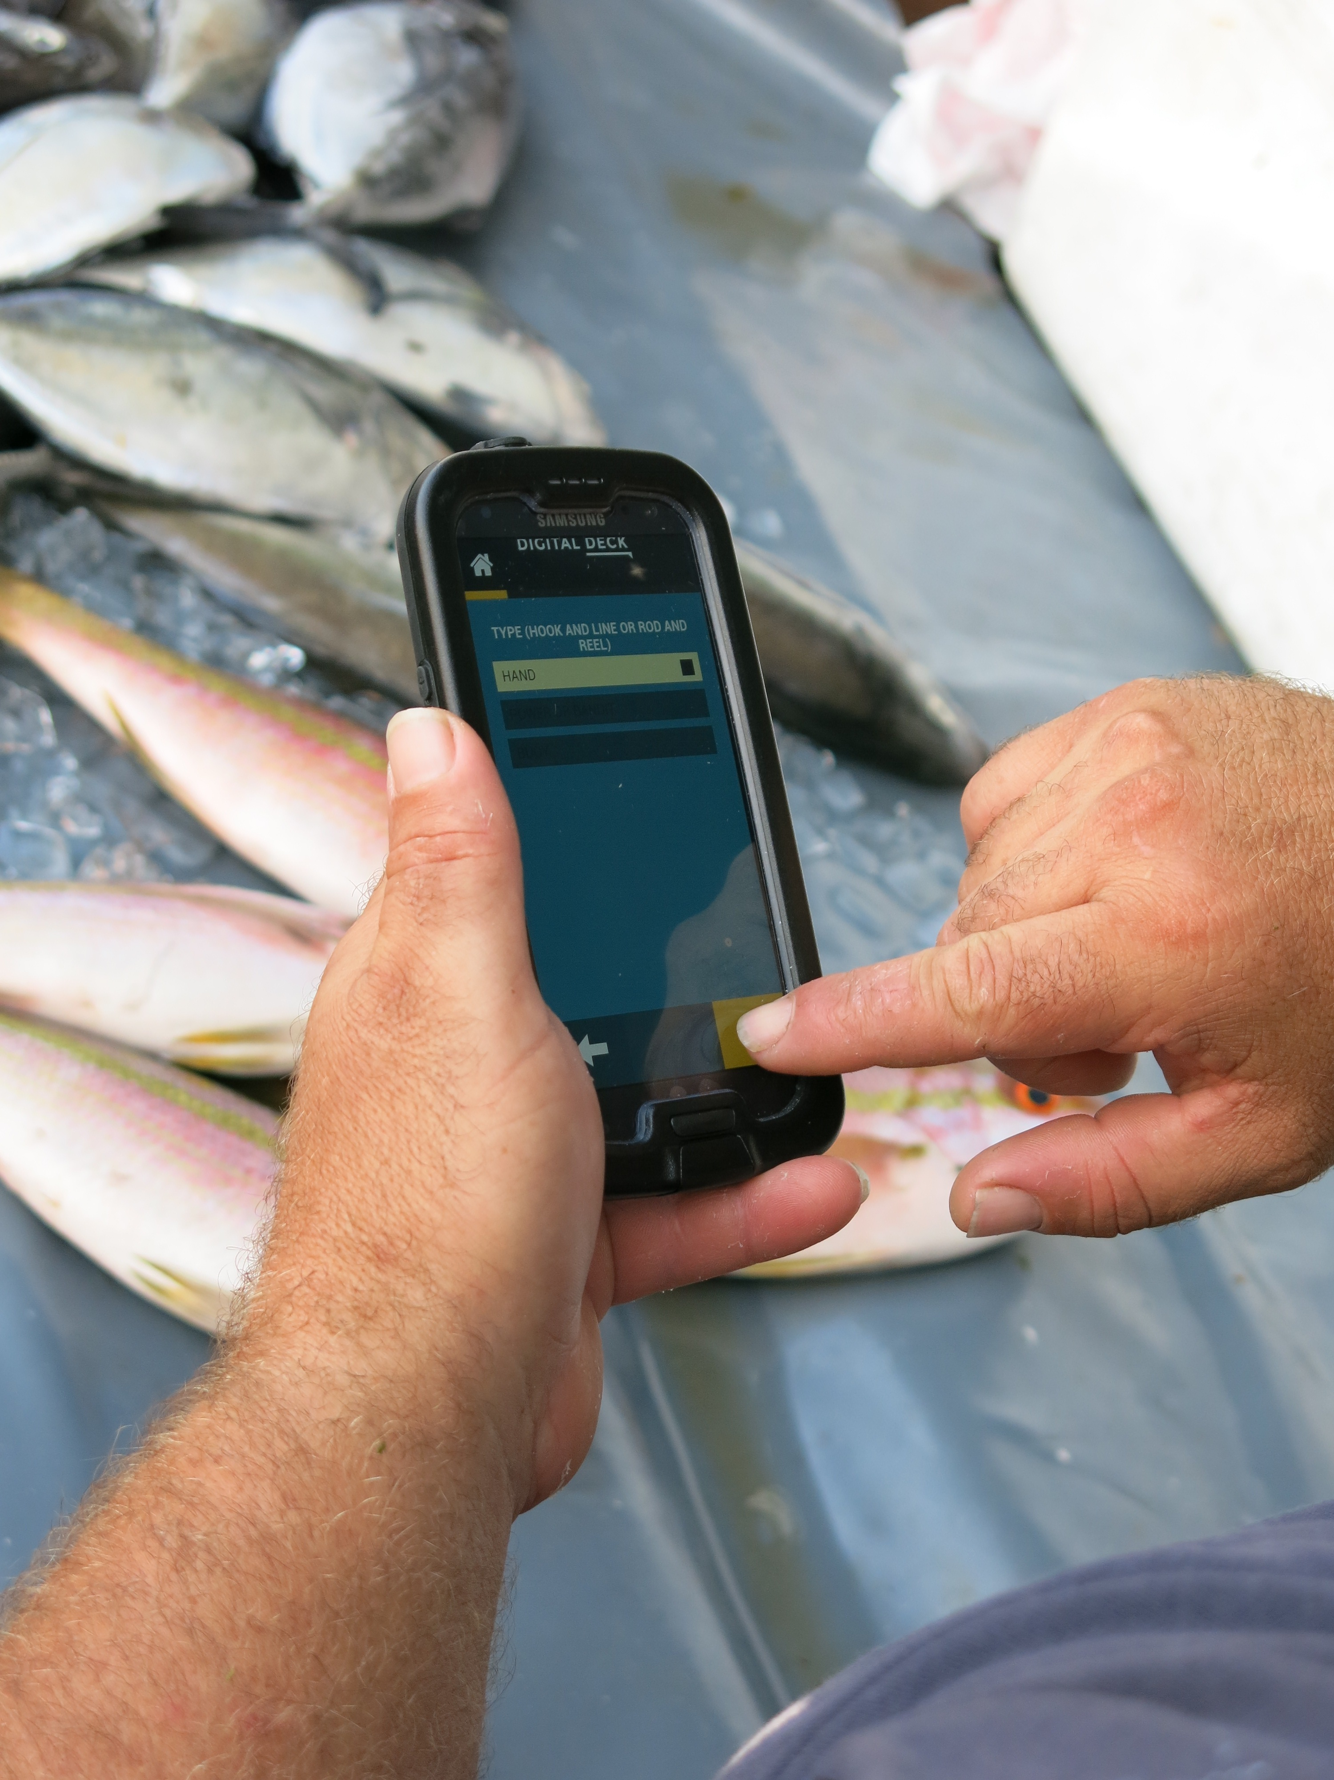

* Packaged technology, consultation and collaboration. Team can customize needs because of its broad background in marine biology, natural resource management, fisheries biology, environmental science, geography, tribal governments, computer science, and GIS.
* Operates on open source. Collaborative; highly customized for each region, use and nuance; integrates with other businesses, computer and users; visible auditable code; more secure.
* High technical skills and production. Robust and useful products that stay in front of tech trends.
* Software development—desktop and mobile. Data collection, analysis and synthesis.
* Technical building and on-site training. Putting tools into the hands of clients and users.

**About Point 97**

Point 97 is the first high-tech, for profit spin-off of Ecotrust, delivering technology solutions and engagement strategies for coastal and marine planning in regions around the world. Working to improve marine and coastal management practices, Point 97 helps partners and clients strengthen coastal communities and ocean ecosystems, bridge different ocean user perspective and implement management decisions in an inclusive and transparent way. Learn more at [pointnineseven.com.](http://www.pointnineseven.com)

**###**